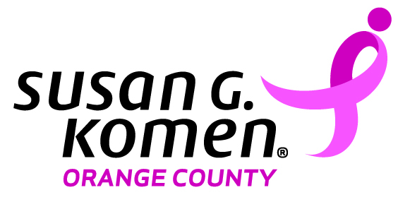 | 2018 Komen Outstanding Breast Health Advocate Award  Nomination Form
Susan G. Komen® Orange County is currently accepting nominations for the
2018 Komen Outstanding Breast Health Advocate Award

Please help us select the individual by completing this nomination form. You may type or write directly onto this form, or simply print it out, fill it out, e-mail or fax it in!

Nomination Deadline Extended to: Monday, July 9, 2018

Please click on the gray boxes to enter text.
I, would like to nominate for the 2018 Komen Outstanding Breast Health Advocate Award.
My address:
My phone number:
My e-mail address:
Nominee’s address:
Nominee’s phone number:
Nominee’s e-mail address:

The final award recipients and those that are nominated will be recognized at our annual Survivor Celebration Tea and Awards Event on August 5, 2018. The winner will receive a complimentary “Pamper Day” including beauty treatments, lunch and shopping donated by Fashion Island Newport Beach! For 2018, we have a new location and a new format, so mark your calendars and save the date!

Award Criteria:
- Individual must practice in Orange County.
- Individual must not be a previous winner in this category.
- Through efforts, individual has demonstrated a commitment to educating the community with life-saving messages about the importance of early detection and making healthy lifestyle choices.

Please complete page two (2) of this nomination form.
Why do you find this person to be an outstanding breast health advocate?
How has this person gone beyond the scope of his/her work to make a difference in the community?

For more information, please call Jennifer Nguyen at 714-957-9157 Ext. 41

Please return nomination form by June 29, 2018 to:

jnguyen@komenoc.org or fax to 714.957.9155

